**Simplify each expression completely.**

1. 
2. 
3. 
4. 
5. 
6. 
7. 
8. 
9. 
10. 
11. 
12. 
13. 
14. 
15. 
16. 
17. 
18. 
19. 
20. 
21. 
22. 
23. 

**Solve. Be sure to check your answers!!**

1. 
2. 
3. 
4. 
5. 
6. 
7. 
8. 
9. 
10. 
11. 
12. 
13. 

**Solve for the unknown.**

1. 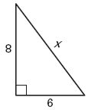
2. 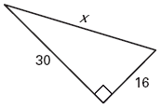
3. 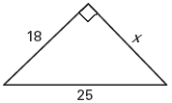
4. 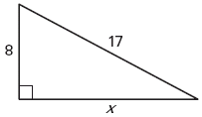
5. 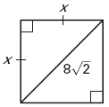
6. 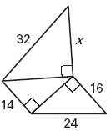

**Find the distance between the points.**

1. 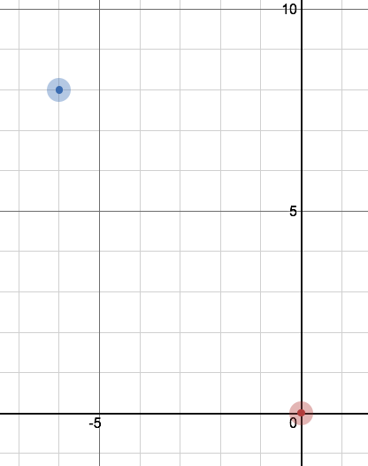
2. 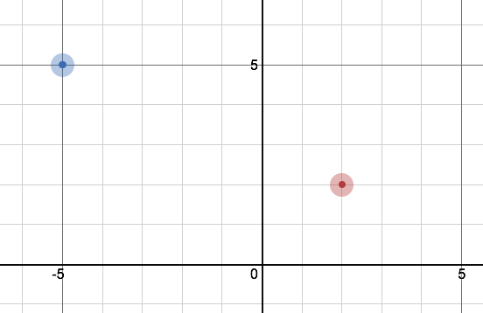
3. 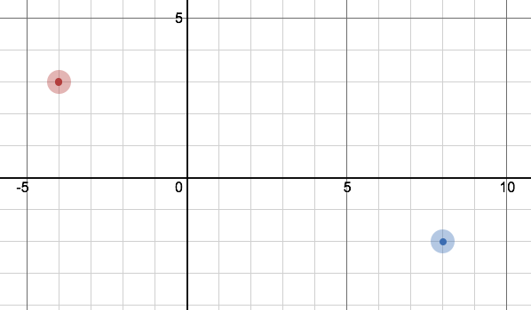

**Solve each of the following problems. Be sure to show all your work.**

1. A 20 foot ladder is resting against the side of a house. The base of the ladder is 4 feet away from the house. Approximately how high above the ground does the ladder touch the house?
2. In slow-pitch softball, the distance of the paths between each pair of consecutive bases is 65 feet and the paths form right angles. Find the distance the catcher must throw a baseball from 3 feet behind home plate to second base.
3. 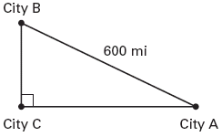 A small commuter airline flies to three cities whose locations form the vertices of a right triangle. The total flight distance (from city A to city B to city C and back to city A) is 1400 miles. It is 600 miles between the two cities that are furthest apart. Find the other two distances