Classwork

Example 1: Calculating the Standard Deviation

Here is a dot plot of the lives of the Brand A batteries from Lesson 4.



How do you measure variability of this data set? One way is by calculating **standard deviation**.

* First, find each deviation from the mean.
* Then, square the deviations from the mean. For example, when the deviation from the mean is the squared deviation from the mean is .

|  |  |  |  |  |  |  |
| --- | --- | --- | --- | --- | --- | --- |
| Life (Hours) |  |  |  |  |  |  |
| Deviation from the Mean |  |  |  |  |  |  |
| Squared Deviations from the Mean |  |  |  |  |  |  |

* Add up the squared deviations:

.

This result is the *sum* of the squared deviations.

The number of values in the data set is denoted by . In this example, is .

* You divide the sum of the squared deviations by , which here is .
* Finally, you take the square root of , which to the nearest hundredth is .

That is the standard deviation! It seems like a very complicated process at first, but you will soon get used to it.

We conclude that a typical deviation of a Brand A battery lifetime from the mean battery lifetime for Brand A is hours. The unit of standard deviation is always the same as the unit of the original data set. So, the standard deviation to the nearest hundredth, with the unit, is hours.

How close is the answer to the typical deviation that you estimated at the beginning of the lesson?

Exercises 1–5

Now you can calculate the standard deviation of the lifetimes for the eight Brand B batteries. The mean was . We already have the deviations from the mean.

|  |  |  |  |  |  |  |  |  |
| --- | --- | --- | --- | --- | --- | --- | --- | --- |
| Life (Hours) |  |  |  |  |  |  |  |  |
| Deviation from the Mean |  |  |  |  |  |  |  |  |
| Squared Deviation from the Mean |  |  |  |  |  |  |  |  |

1. Write the squared deviations in the table.
2. Add up the squared deviations. What result do you get?
3. What is the value of for this data set? Divide the sum of the squared deviations by , and write your answer below. Round your answer to the nearest thousandth.
4. Take the square root to find the standard deviation. Record your answer to the nearest hundredth.
5. How would you interpret the standard deviation that you found in Exercise 4? (Remember to give your answer in the context of this question. Interpret your answer to the nearest hundredth.)

Exercises 6–7

Jenna has bought a new hybrid car. Each week for a period of seven weeks, she has noted the fuel efficiency (in miles per gallon) of her car. The results are shown below.

1. Calculate the standard deviation of these results to the nearest hundredth. Be sure to show your work.
2. What is the meaning of the standard deviation you found in Exercise 6?

**Example 2**

Your teacher will show you how to use a calculator to find the mean and standard deviation for the following set of data.

A set of eight men have heights (in inches) as shown below.

Indicate the mean and standard deviation you obtained from your calculator to the nearest hundredth.

Mean: ____________________

Standard Deviation: ____________________

Exercise 8

1. The heights (in inches) of nine women are as shown below.

Use the statistical features of your calculator or computer software to find the mean and the standard deviation of these heights to the nearest hundredth.

Mean: ____________________

Standard Deviation: ____________________

Exploratory Challenge/Exercises 9-12

1. A group of people attended a talk at a conference. At the end of the talk, ten of the attendees were given a questionnaire that consisted of four questions. The questions were optional, so it was possible that some attendees might answer none of the questions, while others might answer ,,,or all of the questions (so, the possible numbers of questions answered are ,,, , and ).

Suppose that the numbers of questions answered by each of the ten people were as shown in the dot plot below.

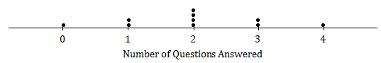

Use the statistical features of your calculator to find the mean and the standard deviation of the data set.

Mean: ____________________

Standard Deviation: ____________________

1. Suppose the dot plot looked like this:

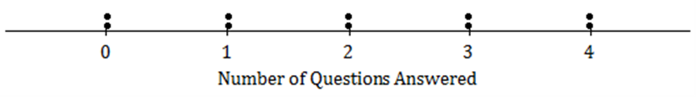

* 1. Use your calculator to find the mean and the standard deviation of this distribution.
  2. Remember that the size of the standard deviation is related to the size of the deviations from the mean. Explain why the standard deviation of this distribution is greater than the standard deviation in Exercise 2.

1. Suppose that all ten people questioned answered all four questions on the questionnaire.
   * + - 1. What would the dot plot look like?

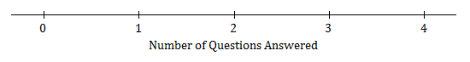

* + - * 1. What is the mean number of questions answered? (You should be able to answer without doing any calculations!)
        2. What is the standard deviation? (Again, don’t do any calculations!)

1. Continue to think about the situation previously described where the numbers of questions answered by each of ten people was recorded.
   1. Draw the dot plot of the distribution of possible data values that has the largest possible standard deviation. (There were ten people at the talk, so there should be ten dots in your dot plot.) Use the scale given below.



* 1. Explain why the distribution you have drawn has a larger standard deviation than the distribution in Exercise 4.

Lesson Summary

* The standard deviation measures a typical deviation from the mean.
* To calculate the standard deviation,

1. Find the mean of the data set;
2. Calculate the deviations from the mean;
3. Square the deviations from the mean;
4. Add up the squared deviations;
5. Divide by (if you are working with a data from a sample, which is the most common case);
6. Take the square root.

* The unit of the standard deviation is always the same as the unit of the original data set.
* The larger the standard deviation, the greater the spread (variability) of the data set.
* The size of the standard deviation is related to the sizes of the deviations from the mean. Therefore, the standard deviation is minimized when all the numbers in the data set are the same and is maximized when the deviations from the mean are made as large as possible.

Practice:

1. A small car dealership tests the fuel efficiency of sedans on its lot. It chooses sedans for the test. The fuel efficiency (mpg) values of the cars are given in the table below. Complete the table as directed below.

|  |  |  |  |  |  |  |  |  |  |  |  |  |
| --- | --- | --- | --- | --- | --- | --- | --- | --- | --- | --- | --- | --- |
| Fuel Efficiency (miles per gallon) |  |  |  |  |  |  |  |  |  |  |  |  |
| Deviation from the Mean |  |  |  |  |  |  |  |  |  |  |  |  |
| Squared Deviation from the Mean |  |  |  |  |  |  |  |  |  |  |  |  |

* 1. Calculate the mean fuel efficiency for these cars. Calculate the mean fuel efficiency for these cars.
  2. Calculate the deviations from the mean, and write your answers in the second row of the table.
  3. Square the deviations from the mean, and write the squared deviations in the third row of the table.
  4. Find the sum of the squared deviations.
  5. What is the value of for this data set? Divide the sum of the squared deviations by .
  6. Take the square root of your answer to (e) to find the standard deviation of the fuel efficiencies of these cars. Round your answer to the nearest hundredth.

1. The same dealership decides to test fuel efficiency of SUVs. It selects six SUVs on its lot for the test. The fuel efficiencies (in miles per gallon) of these cars are shown below.

Calculate the mean and the standard deviation of these values. Be sure to show your work, and include a unit in your answer.

1. Consider the following questions regarding the cars described in Problems 1 and 2.
   1. What is the standard deviation of the fuel efficiencies of the cars in Problem 1? Explain what this value tells you.
   2. You also calculated the standard deviation of the fuel efficiencies for the cars in Problem 2. Which of the two data sets (Problem 1 or Problem 2) has the larger standard deviation? What does this tell you about the two types of cars (sedans and SUVs)?
2. At a track meet, there are three men’s m races. The times for eight of the sprinters are recorded to the nearest of a second. The results of the three races for these eight sprinters are shown in the dot plots below.

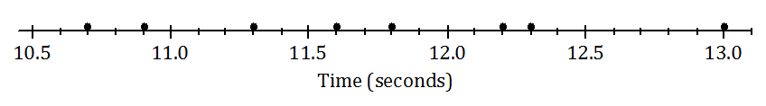

Race 1

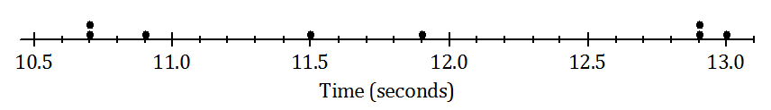

Race 2

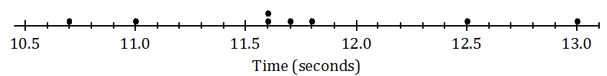

Race 3

* 1. Remember that the size of the standard deviation is related to the sizes of the deviations from the mean. Without doing any calculations, indicate which of the three races has the smallest standard deviation of times. Justify your answer.
  2. Which race had the largest standard deviation of times? (Again, don’t do any calculations!) Justify your answer.
  3. Roughly what would be the standard deviation in Race 1?   
     (Remember that the standard deviation is a typical deviation from the mean. So, here you are looking for a typical deviation from the mean, in seconds, for Race 1.)
  4. Use your calculator to find the mean and the standard deviation for each of the three races. Write your answers in the table below to the nearest thousandth.

|  |  |  |
| --- | --- | --- |
|  | Mean | Standard Deviation |
| Race 1 |  |  |
| Race 2 |  |  |
| Race 3 |  |  |

* 1. How close were your answers (a)–(c) to the actual values?

1. A large city, which we will call City A, holds a marathon. Suppose that the ages of the participants in the marathon that took place in City A were summarized in the histogram below.

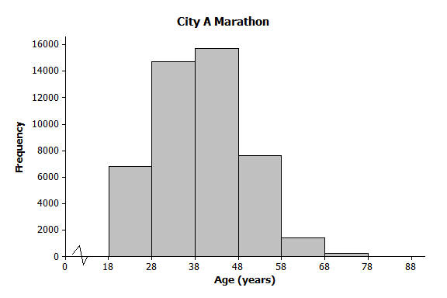

* 1. Make an estimate of the mean age of the participants in the City A marathon.
  2. Make an *estimate* of the standard deviation of the ages of the participants in the City A marathon.

A smaller city, City B, also held a marathon. However, City B restricts the number of people of each age category who can take part to . The ages of the participants for one race are summarized in the histogram below. The ages of the participants are summarized in the histogram below.

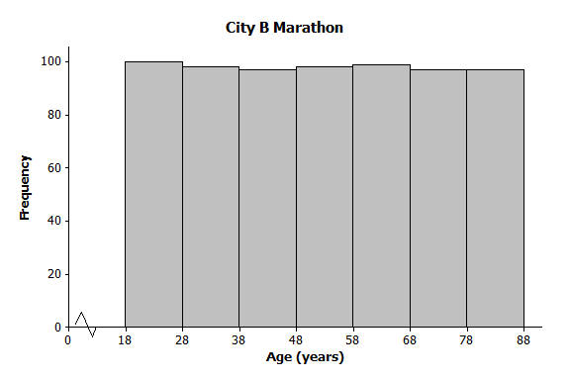

* 1. Approximately what was the mean age of the participants in the City B marathon? Approximately what was the standard deviation of the ages?
  2. Explain why the standard deviation of the ages in the City B marathon is greater than the standard deviation of the ages for the City A marathon.