Complete the Unit Circle by labeling the angles in degrees and labeling the points with their exact value (x, y) coordinate pair.

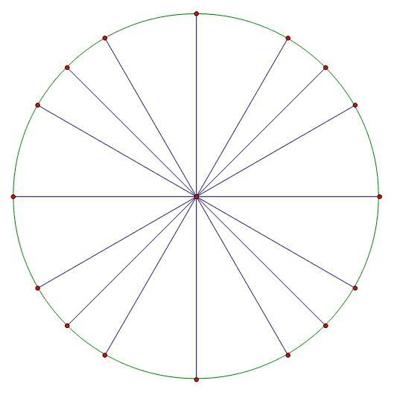

Just in case you need an extra circle ;)

