**9-8.1 HW: All kinds of quadrilateral proofs**

1.



|  |  |
| --- | --- |
| Statements | Reasons |
| 1. | 1. |
| 2. | 2. |
| 3. | 3. |
| 4. | 4. |
| 5. | 5. |
| 6. | 6. |
| 7. | 7. |
| 8. | 8. |
| 9. | 9. |
| 10. | 10. |
| 11. | 11. |
| 12. | 12. |
| 13. | 13. |
| 14. | 14. |

2.



|  |  |
| --- | --- |
| Statements | Reasons |
| 1. | 1. |
| 2. | 2. |
| 3. | 3. |
| 4. | 4. |
| 5. | 5. |
| 6. | 6. |
| 7. | 7. |
| 8. | 8. |
| 9. | 9. |
| 10. | 10. |
| 11. | 11. |
| 12. | 12. |
| 13. | 13. |
| 14. | 14. |

3.

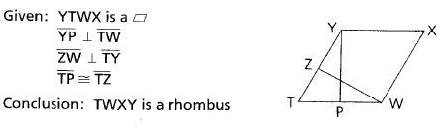

|  |  |
| --- | --- |
| Statements | Reasons |
| 1. | 1. |
| 2. | 2. |
| 3. | 3. |
| 4. | 4. |
| 5. | 5. |
| 6. | 6. |
| 7. | 7. |
| 8. | 8. |
| 9. | 9. |
| 10. | 10. |
| 11. | 11. |
| 12. | 12. |
| 13. | 13. |
| 14. | 14. |
| 15. | 15. |
| 16. | 16. |

4.

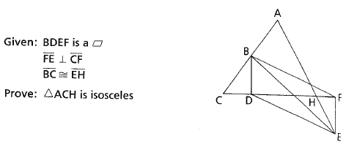

|  |  |
| --- | --- |
| Statements | Reasons |
| 1. | 1. |
| 2. | 2. |
| 3. | 3. |
| 4. | 4. |
| 5. | 5. |
| 6. | 6. |
| 7. | 7. |
| 8. | 8. |
| 9. | 9. |
| 10. | 10. |
| 11. | 11. |
| 12. | 12. |
| 13. | 13. |
| 14. | 14. |
| 15. | 15. |
| 16. | 16. |

5.



|  |  |
| --- | --- |
| Statements | Reasons |
| 1. | 1. |
| 2. | 2. |
| 3. | 3. |
| 4. | 4. |
| 5. | 5. |
| 6. | 6. |
| 7. | 7. |
| 8. | 8. |
| 9. | 9. |
| 10. | 10. |
| 11. | 11. |
| 12. | 12. |
| 13. | 13. |
| 14. | 14. |
| 15. | 15. |
| 16. | 16. |

6. 

|  |  |
| --- | --- |
| Statements | Reasons |
| 1. | 1. |
| 2. | 2. |
| 3. | 3. |
| 4. | 4. |
| 5. | 5. |
| 6. | 6. |
| 7. | 7. |
| 8. | 8. |
| 9. | 9. |
| 10. | 10. |
| 11. | 11. |
| 12. | 12. |
| 13. | 13. |
| 14. | 14. |
| 15. | 15. |
| 16. | 16. |

7.



|  |  |
| --- | --- |
| Statements | Reasons |
| 1. | 1. |
| 2. | 2. |
| 3. | 3. |
| 4. | 4. |
| 5. | 5. |
| 6. | 6. |
| 7. | 7. |
| 8. | 8. |
| 9. | 9. |
| 10. | 10. |
| 11. | 11. |
| 12. | 12. |
| 13. | 13. |
| 14. | 14. |
| 15. | 15. |
| 16. | 16. |