8b FLOODLIGHTS--Task 2

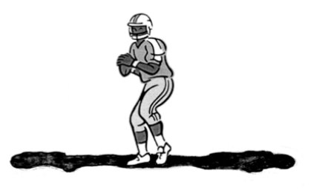

Eliot is playing football.
He is 6 feet tall.
He stands exactly halfway between two floodlights.
The floodlights are 12 yards high and 50 yards apart.
The floodlights give Eliot two shadows, falling in opposite directions.

- Suppose Eliot walks in a straight line towards one of the floodlights. Figure out what happens to the total length of Eliot’s shadows. Explain your reasoning in detail.

- Now that you’ve seen some ways other groups have approached the problem, it’s time to take a second look at your work. Revise your solution method and produce a detailed explanation of how you would solve the problem.

