8b FLOODLIGHTS--Task 1

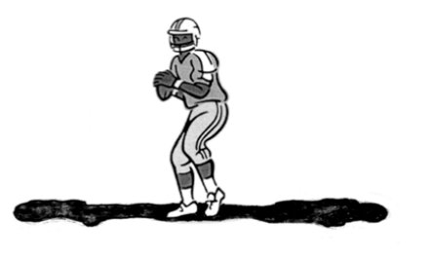

Eliot is playing football.
He is 6 feet tall.
He stands exactly halfway between two floodlights.
The floodlights are 12 yards high and 50 yards apart.
The floodlights give Eliot two shadows, falling in opposite directions.

- Draw a diagram to represent this situation. Label your diagram with measures.

- Find the total length of Eliot’s shadows. Explain your reasoning IN DETAIL.

- Now that you’ve seen some ways other groups have approached the problem, it’s time to take a second look at your work. Revise your solution method and produce a detailed explanation of how you would solve the problem.

