Spending Per Student in Some Schools

4037
8882
4611
4280
4921
5097
8473
6621
10180
5516
4915
5879
3844
5893
5630
5288
5659
5107
4519
6069
6958
6959
6658
5720
3660
5114
5598
5651
5049
5723
9677
4261
9175
4894
4674
5971
4697
6263
6983
7333
4761
4586
4149
4898
3439
6600
5109
5751
5713
6717
5899
- Create a histogram of the data with the interval size (width of your bars) of $500 starting at $3000. USE GRAPH PAPER.

- Create a 5 number summary of the data. Be sure to show your work
(i.e. I will take points off for not showing your work)

- Are there any outliers in the data? Use the test for outliers to give a definitive answer. Be sure to show your work (i.e. I will take points off for not showing your work)

- Create a box plot of the same data below or above your histogram. If this isn’t possible, be sure to use the same scale when creating the box plot as you used on your histogram. Your answer to number 3) should factor into your box plot. USE GRAPH PAPER.

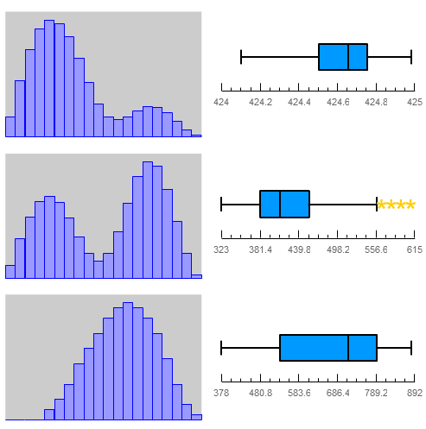
- Match the histogram with
the correct box plot?

Draw lines between the
ones you think go together.

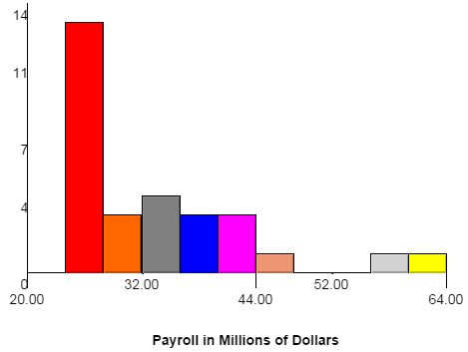
- Do your best to create a box plot from the following histogram. Make your box plot below the histogram using the same scale.

13 3 4 3 3 2 0 0 1 1

Draw Box Plot Here.

- Students were given the opportunity to prepare for a college placement test in mathematics by taking a review course. Not all students took advantage of this opportunity. The following results were obtained from a random sample of students who took the placement test.
Fill in the missing cell values.
 | Placed in Math 200 | Placed in Math 100 | Placed in Math 50 | Total
Took Review Course | $$40$$ |  | $$7$$ | $$60$$
Did Not Take Review Course |  | $$15$$ | $$15$$
Total | $$50$$ | $$28$$ |  | $$100$$

- Construct a row conditional relative frequency table of the above data.
 | Placed in Math 200 | Placed in Math 100 | Placed in Math 50 | Total
Took Review Course
Did Not Take Review Course
Total

- Based on the conditional relative frequencies, is there evidence of an association between whether a student takes the review course and the math course in which the student was placed? Explain your answer.

- How does the standard deviation of the first graph compare with the standard deviation of the second graph? Be as detailed in your answer as you can.
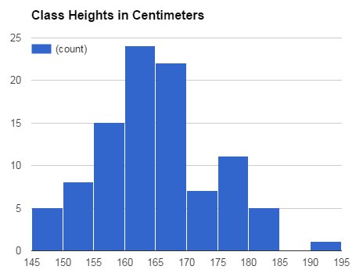
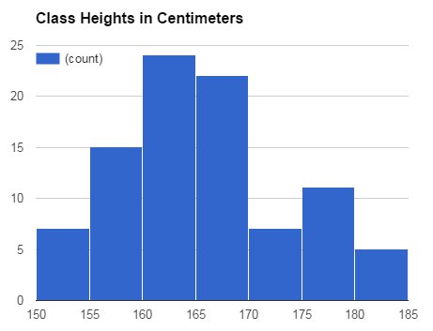
Graph 1 Graph 2

- A small car dealership tests the fuel efficiency of sedans on its lot. It chooses $12$ sedans for the test. The fuel efficiency (mpg) values of the cars are given in the table below. Use the table to calculate the standard deviation.

Fuel Efficiency (miles per gallon) | $$29$$ | $$35$$ | $$24$$ | $$25$$ | $$21$$ | $$21$$ | $$18$$ | $$28$$ | $$31$$ | $$26$$ | $$26$$ | $$22$$
Deviation from the Mean
Squared Deviation from the Mean

