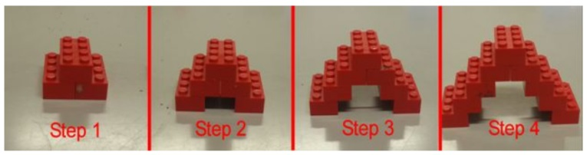
For all problems do three things: 1) draw the next step 2) find the value of the 50th term 3) find an equation which describes the pattern.
1)

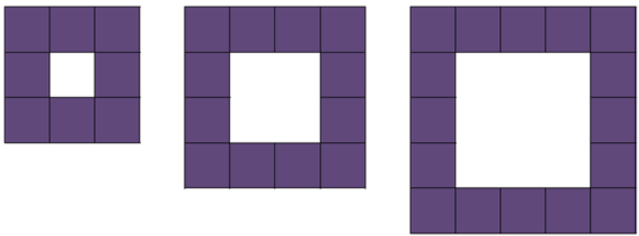
2) 1. 2. 3.

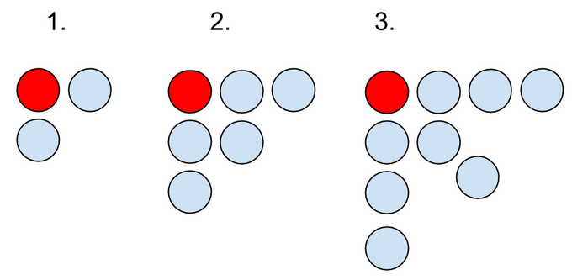
3)

Create an equation which represents each table of values.
4)
x | 0 | 1 | 2 | 3
y | 0 | 4 | 8 | 12

5)
x | 0 | 1 | 2 | 3
y | 5 | 9 | 13 | 17

6)
X | 0 | 1 | 2 | 3
Y | 15 | 12 | 9 | 6

7)
x | 0 | 1 | 2 | 3
y | 30 | 34 | 38 | 42

8)
X | 0 | 1 | 2 | 3
Y | -8 | -12 | -16 | -20

9)
x | 0 | 1 | 2 | 3
y | 11 | 21 | 31 | 41

Be careful with these next ones!
10)
x | 1 | 2 | 3 | 4
y | 7 | 6 | 5 | 4

11)
x | 1 | 2 | 3 | 4
y | 17 | 19 | 21 | 23

12)
x | 1 | 2 | 3 | 4
y | 20 | 25 | 30 | 35

