4.4 Practice #35 and #36

Use a compass and straightedge to construct two lines of reflection that produce a composition of reflections resulting in the same image as the given transformation.

35.
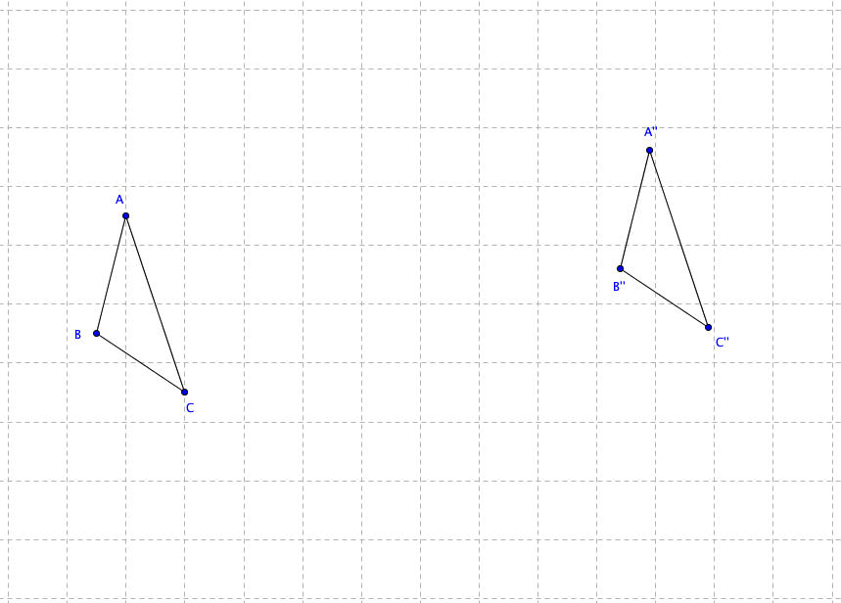

36.
