Given the amplitude, period, horizontal shift, vertical shift and whether or not there is a reflection over the x-axis: 1) write the function and 2) graph the function.
- amplitude: 1.5, period: π, horizontal shift: π/2, vertical shift: 4, reflection? no

y =

- amplitude: 5, period: 2π/3, horizontal shift: 0, vertical shift: -2, reflection?: yes

y =

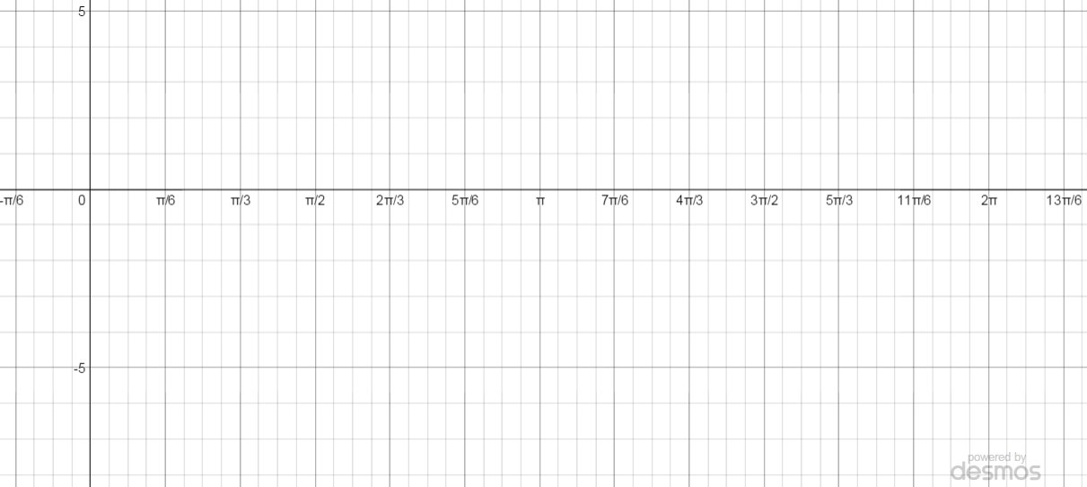
Given the equation, 1) list the amplitude, period, horizontal shift, vertical shift and whether or not there is a reflection over the x-axis and then 2) graph the function.
- $y=\cos\left(x-\frac{π}{3}\right)+2$

amp.: ____, period: ____, horiz. shift: ____, vert. shift: ____, reflection?: ____

- $y=1.5cos\left(2(x-\frac{π}{6})\right)-1$ [Careful! The horizontal shift is NOT $\frac{π}{6}$ ]

amp.: ____, period: ____, horiz. shift: ____, vert. shift: ____, reflection?: ____

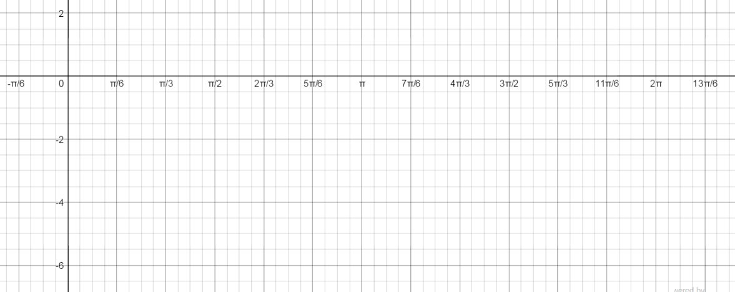
- $y=-2cos\left(3(x+\frac{π}{2})\right)$ [Careful!]

amp.: ____, period: ____, horiz. shift: ____, vert. shift: ____, reflection?: ____

Given the following graphs, 1) list the amplitude, period, horizontal shift, vertical shift and whether or not there is a reflection over the x-axis and then 2) write the equation for the function.
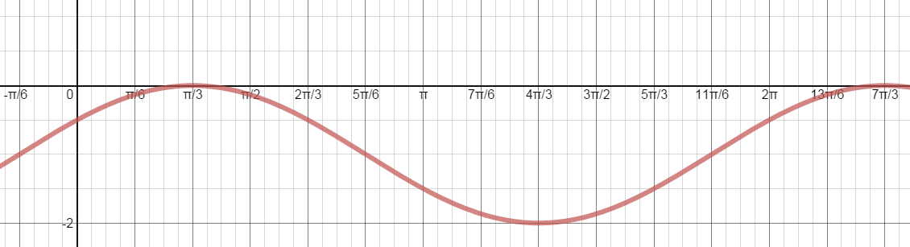
Amp
Period
Horizontal
Shift
Vertical
Shift

- y =

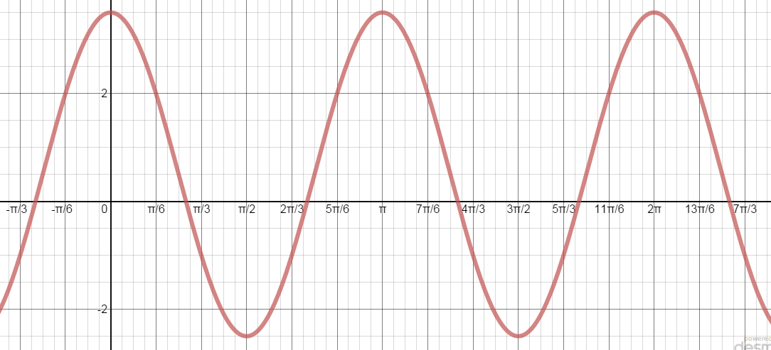

- y =
Amp
Period
Horizontal
Shift
Vertical
Shift

