|  |  |
| --- | --- |
| Top-left | Top-right |
| Bottom-left | Bottom-right |

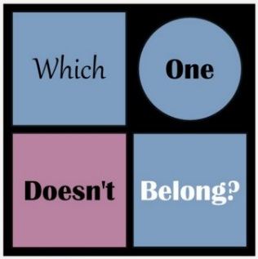



As a group, create a WODB for 3 families of functions:

* Linear
* Exponential
* Quadratic
* Square Root
* Rational

You must have graphs **and** equations for each box. You may use inequalities. Your graphs must be reasonably accurate.

|  |
| --- |
| How is the top-left different from the others? |
| How is the top-right different from the others? |
| How is the bottom-left different from the others? |
| How is the bottom-right different from the others? |

|  |  |
| --- | --- |
| Top-left | Top-right |
| Bottom-left | Bottom-right |





As a group, create a WODB for 3 families of functions:

* Linear
* Exponential
* Quadratic
* Square Root
* Rational

You must have graphs **and** equations for each box. You may use inequalities. Your graphs must be reasonably accurate.

|  |
| --- |
| How is the top-left different from the others? |
| How is the top-right different from the others? |
| How is the bottom-left different from the others? |
| How is the bottom-right different from the others? |