Design Rational Functions which meet these requirements:

- f(x) so that the function…
  - has a root at x= 8

  - has a vertical asymptote at x= -5

- g(x) so that the function…
  - has a root at x= -1/2

  - has a vertical asymptote at x= 3

- h(x) so that the function…
  - has a root at x= 4

  - has a vertical asymptote at x= 1

  - has a horizontal asymptote at y = 2

- j(x) so that the function…
  - has a root at x=3/2

  - has a vertical asymptote at x= 4/5

  - has a horizontal asymptote at y = 2

- k(x) so that the function…
  - is positive on the left side of the vertical asymptote

- m(x) so that the function…
  - is positive on the left side of the vertical asymptote

  - has a root at x= 3

  - has a vertical asymptote at x= 1/2

  - has a horizontal asymptote at y = -4

Given the following graphs of functions, give me a possible function which satisfies both the graph’s roots and the graph’s asymptotes.
- 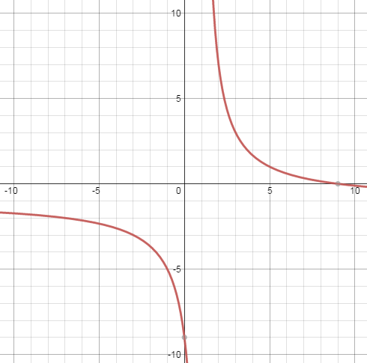 8) 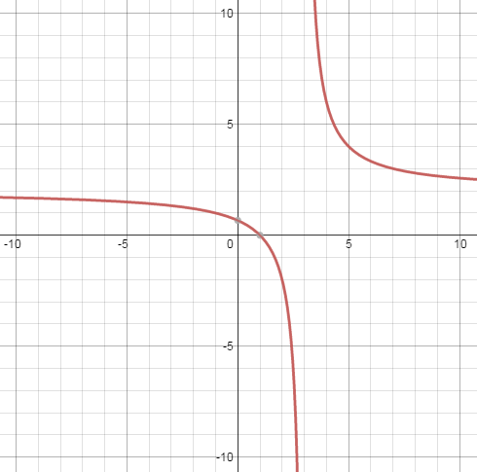

- 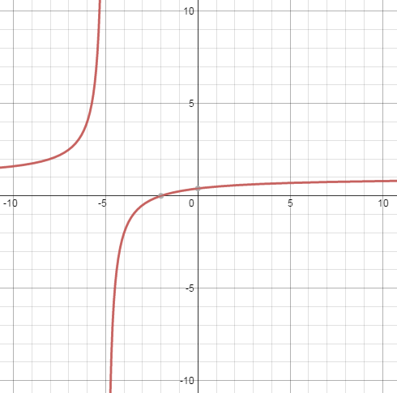 10) 

 