Algebra 1B 11a Graphs of Rational Expressions

Complete the numbered tasks. Read everything. Discuss your responses with your partner/group and be prepared to share them with the class.

1. Your favorite way to explain why a number divided by zero is undefined: ________________________________

_______________________________________________________________________________________________________________________

_______________________________________________________________________________________________________________________

_______________________________________________________________________________________________________________________

2. The graph shows two linear functions, f(x) and g(x). For each different x, calculate the quotient . Graph the result on the same set of axes. Use the table to help you if you wish.

|  |  |  |  |
| --- | --- | --- | --- |
| *x* | *f(x)* | *g(x)* |  |
| -1 |  |  |  |
| 0 |  |  |  |
| 1 |  |  |  |
| 2 |  |  |  |
| 3 |  |  |  |
| 4 |  |  |  |
| 5 |  |  |  |
| 6 |  |  |  |
| 7 |  |  |  |
| 8 |  |  |  |
| 9 |  |  |  |
| 10 |  |  |  |

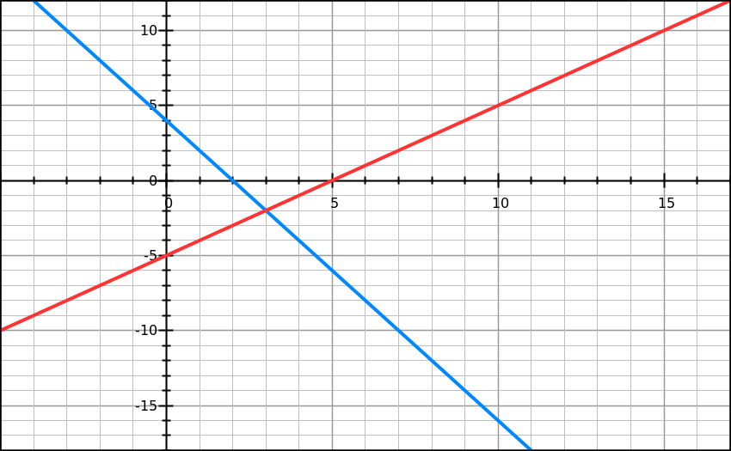

*f(x)*

*g(x)*

3. In addition to the points you already plotted, also plot the outcome at *x* = 4.5 and *x* = 5.5.

4. What is the equation of our new function? 

Graph it in your calculator to check that your equation matches the graph.

What window should you use? Xmin:______ Xmax: ______ Ymin: ______ Ymax: ______

Exactly what are you typing in Y= _______________________________

5. What are the roots (x-intercepts) of the new function? _____________________________________________________

6. What about the original graphs f(x) and g(x) determined where the root of the new graph would be? _______________________________________________________________________________________________________________________

_______________________________________________________________________________________________________________________

_______________________________________________________________________________________________________________________

7. What is the domain (usable *x*’s) of this function?_____________________________________________________________

_______________________________________________________________________________________________________________________

_______________________________________________________________________________________________________________________

8. What about the original graphs f(x) and g(x) restricted the domain (made a certain x value impossible)? _______________________________________________________________________________________________________

_______________________________________________________________________________________________________________________

_______________________________________________________________________________________________________________________

9. Isn’t it weird that we can make a function out of linear functions and get an impossible *x*? Yes / No

10. If we only had the equation, and not the graph, how could we find where these impossible values of *x* are located? ________________________________________________________________________________________________________

______________________________________________________________________________________________________________________

______________________________________________________________________________________________________________________

11. I’m going to need you to go ahead and apply this knowledge.

What values of *x* make the function undefined? Find them algebraically, then check by graphing on calculator.

(a)  (b)  (c) 

12. Check Yo’self: Which line is the numerator, and which is the denominator?

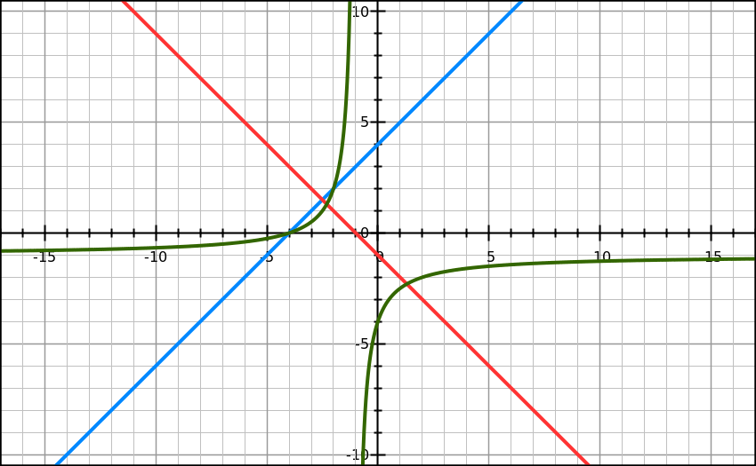

*n(x)*

*k(x)*