Partners, work on your own problems and check with your partner after you have finished a problem. Since the problems are the same, the answers should also be the same. #math Work through any mistakes and ask for help if you need it.

1. 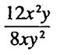

2. 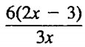

3. 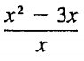

4. 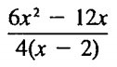

5. 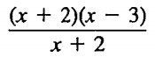

6. 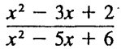

7. 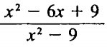

8. 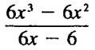

9. 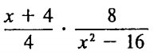

11. 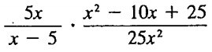

12. 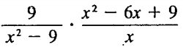

13. 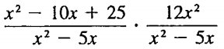

14. 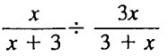

15. 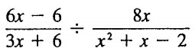

16. 