Now that you are well on your way to becoming experts on quadratic functions, create quadratics fulfilling the requirements for each of the following properties. Sketch the graph for your brilliant solution next to your equation. Each property must have a unique equation.

- Has two x intercepts

- Has one x intercept

- Has no x intercept

- Has two rational roots

- Has one rational double root
- Has one positive and one negative root.

- Has no roots.

- Has two irrational roots.

- Is a reflection over the y-axis

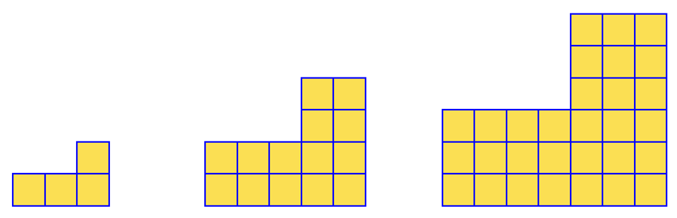
- Draw the next step in the pattern from visualpatterns.org

- Find the number of blocks in step 20. Be sure to show all relevant work for full credit.

- Find an equation. Be sure to show all relevant work for full credit.

