Section 1:
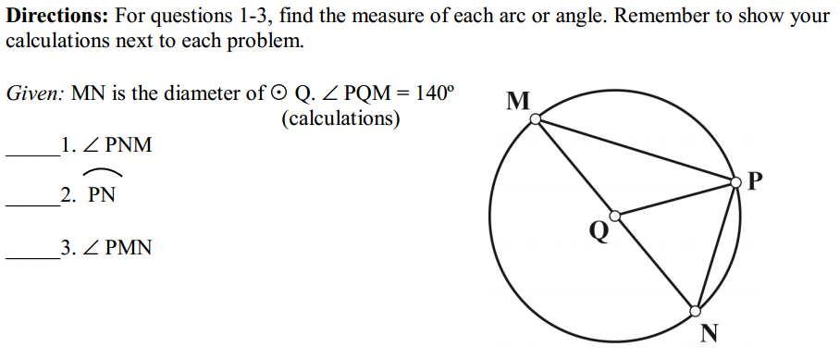
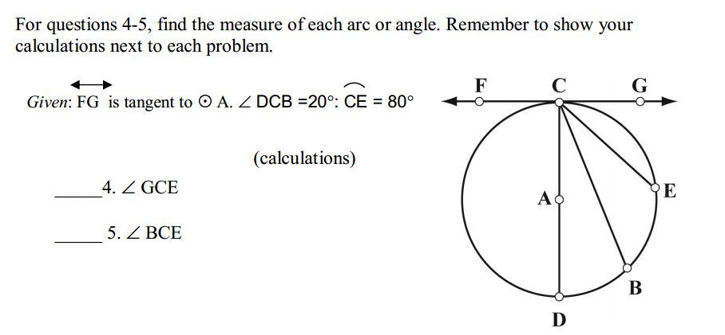
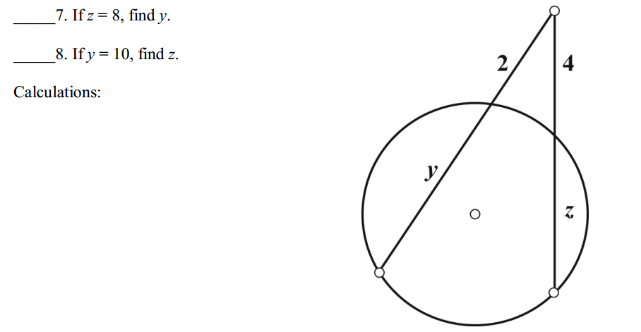
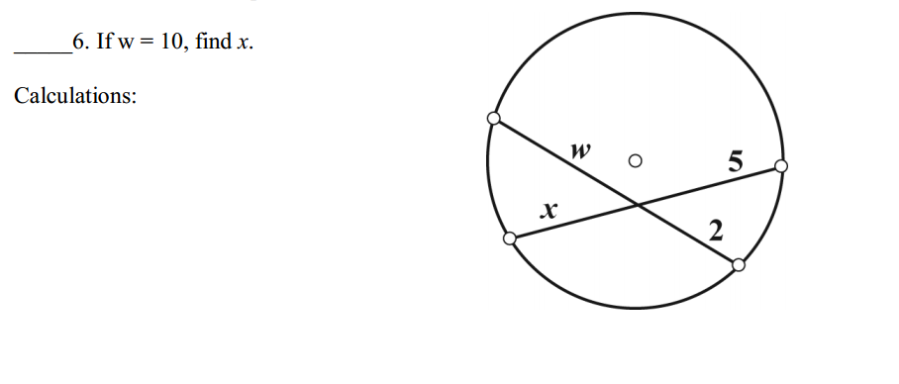

Section 2:
- The average height of the International Space Station is 400 km above the Earth. An astronaut on board the International Space Station sights along a tangent line to Earth, viewing Houston Space Center. If the diameter of the Earth is approximately 12,800 km, how far is the astronaut from the Space Center? Show your calculations; then, explain, in paragraph form, how you found the answer. Note: the drawing is not to scale.
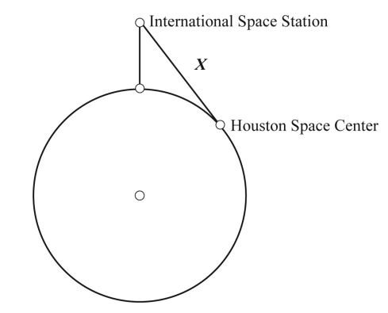

- An inscribed angle intercepts an arc that is 1/5 of the circle. Find the measure of the inscribed angle. Remember to show your calculations.

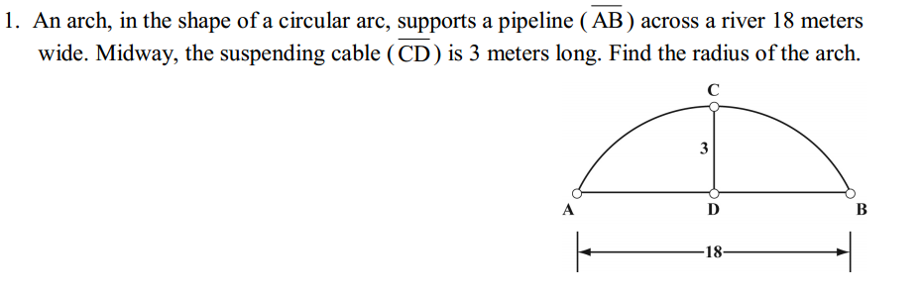
3.

- A puzzle in the form of a quadrilateral is inscribed in a circle. The vertices of the quadrilateral divide the circle into 4 arcs in a ratio of 1:2:5:4. Find the angles of the quadrilateral. After solving this problem, write, in paragraph form, an explanation of how you solved it.

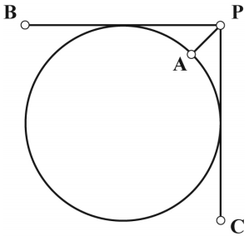
- A circular trashcan is pushed into a corner. The diameter of the can is 60 cm. Find the distance from the corner (P) to the edge of the can (A).

- A conveyor belt is tightly wrapped around circle R, forming a right angle at Q. The circle has a radius of 9 inches. Find the length of the distance from the point on the corner to the closest point on the circle, P. After completing the calculations, write a paragraph explaining how you solved the problem.
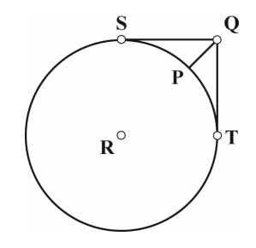

- Two tangent segments to a circle intersect at a point outside the circle. If the sum of their lengths is 35 centimeters, what is the length of each tangent segment?

- A jeweler wants to engrave an inscribed square within a circle of radius 12 cm. Find the length of the side of the square.

- An inscribed angle intercepts an arc that is 1/8 of the circle. Find the measure of the inscribed angle.

