With the high price of gasoline in the U.S., motorists are concerned about the gas mileage of their cars. The table below gives the curb weights and highway mileage for a sample of 2007 four-door compact sedans, all with automatic transmissions.
Car Type | Curb Weight  (in 100 lbs) | Highway mpg
Audi A4 | 34.50 | 32
Chevrolet Cobalt | 32.16 | 32
Ford Focus | 26.36 | 34
Honda Civic | 26.90 | 40
Honda Civic Hybrid | 28.75 | 51
Hyundai Accent | 24.03 | 36
Kia Spectra | 29.72 | 35
Mazda3 | 28.11 | 34
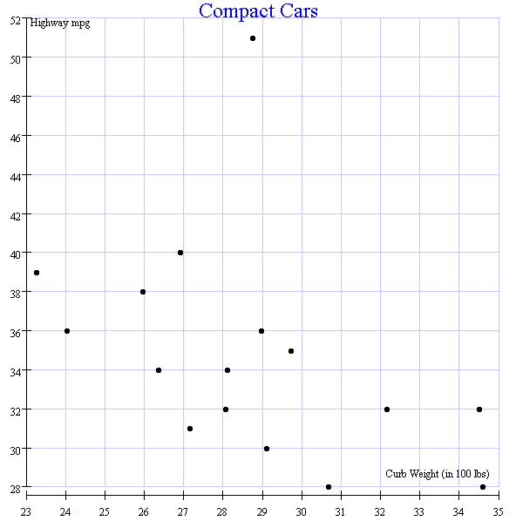

Mercedes-Benz C280 | 34.60 | 28
Nissan Sentra | 28.97 | 36
Saturn ION | 28.05 | 32
Subaru Impreza | 30.67 | 28
Suzuki Aerio | 27.16 | 31
Toyota Corolla | 25.95 | 38
Toyota Yaris | 23.26 | 39
VW Rabbit | 29.11 | 30

This page left blank intentionally

- What is the weight of the Kia Spectra in hundreds of pounds? Of the Toyota Yaris?

- Is there a point on the scatterplot that is an outlier? If so, which car is it? Explain.

- Find the line of best fit: graph the line on the scatterplot and create an equation for your line. Ignore the outlier.

- Enter the compact car data into your lists, ignoring the outlier: StatEdit. Create a linear regression equation for the data.

- Select the best interpretation of the slope of the regression line from the choices below. Explain your choice.
  - If the weight of the car is increased by 100 pounds, then we predict that the car’s highway gas mileage will decrease by about 0.75 mpg.

  - If one model of a car is 100 pounds heavier than another model, then we predict that its highway gas mileage will be 0.75 mpg less.

- A compact car that is not in the table, the Acura TSX, has a weight of 3,345 lbs. Use each of the following to predict the highway mpg for the Acura TSX.
  - Your equation for the line of best fit.

  - The equation of the regression line.

- The Acura TSX has a highway mpg of 31. Using the regression equation, what is the error in prediction for the Acura TSX?

- Draw the errors between our line of best fit and the actual data points on the scatterplot. These values are called residuals.

- The Volkswagen Jetta has a curb weight of 3,303 lbs.
  - Use the regression equation to predict the highway mpg for the Jetta.

  - The Jetta actually has highway mpg of 32. What is the error in the prediction for the Jetta?

