**Section 1:** topics covered in this section

1. Solve linear equations
   1. Solve one step equations
      1. One step equations with integers
      2. One step equations with fractions
      3. One step equations with decimals
   2. Word problems that lead to one step equations
   3. Solve two step equations
   4. Word problems that lead to two step equations
   5. Equations with distribution and like terms
   6. Equations with variables on both sides
   7. Literal equations
   8. Word problems that lead to harder equations

Solve the following equations.

1) -3m +14=5m+38

2) 2(x-3)+7 = 3x-7

3) The table below shows the approximate distance from a lightning strike to an observer based on the time it takes the observer to hear the thunder.

|  |  |  |  |  |  |
| --- | --- | --- | --- | --- | --- |
| Seconds | 2 | 4 | 6 | 8 | 10 |
| Miles | 0.4 | 0.8 | 1.2 |  |  |

a) Complete the   
  
table

b) For each 2-second increase in time, what is the increase in miles?

c) Use this rate of change to calculate the distance in miles for 12, 14, and 16 seconds.

d) The sound of thunder travels 4.4 miles in 22 seconds. Find the distance that the sound of thunder travels in 23 seconds.

4) For the following pattern:

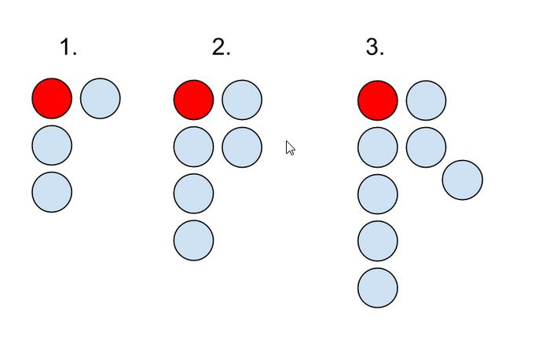

* 1. Draw the next figure in the sequence.
  2. Find the number of blocks in the 5th figure.
  3. Find the number of blocks in the 60th figure.
  4. Create an equation relating the figure number to the number of blocks.

5) Using the following sequence of shapes, find the perimeter of the 43rd figure. Each smaller side has length of one. So, the first figure would have a perimeter of 9. (Challenge: What is the area of the 43rd figure?)



6) In 1992, there were 207,828 women serving in the Armed Forces of the US, accounting for about 11.5% of total military personnel. In all, how many persons were serving in the Armed Forces in 1992?

7) The total cost of a video game was $51.89. This included the 6% sales tax. What was the price of the game without the tax?

8) A motorist traveled 283.5 miles of 9.0 gallons of gas. With the same driving conditions, how far could the car go on 14 gallons of gas?

**Section 2:** topics covered in this section

1. Linear equations
   1. Plot and identify points
   2. Graph lines by making a table
   3. Graph lines by using the slope-intercept form
   4. Graph lines by using the point slope form
   5. Write equations of line
      1. Slope-intercept form
      2. Point-slope form
      3. From information given
      4. From graph
      5. From two points
      6. Horizontal and vertical lines
      7. Parallel to given line
      8. Perpendicular to given line
   6. Word problems that lead to slope-intercept form

1) Find the slope and y-intercept: 4y = 20x + 28

2) The line has a slope of 11 and passes through the point (2.5, -1.5). Find the equation.

3) Write an equation in standard form of the line passing through (-8, 3) with m = 2.

4) Write an equation in slope-intercept form for the line containing the points (3,3) and (5,7).

5) Flooding

A flooded stream is now 3.5 feet above its normal level. The water level is dropping 2 inches per hour. Let y be the height in inches above normal and x be the hours.

1. Create a table for this situation.



1. Create an equation for this situation.
2. Graph the situation
3. How many hours will it take for the water level to fall to normal?

**Section 3:** topics covered in this section

1. Systems of linear equations
   1. Solve by graphing
   2. Solve by substitution
   3. Solve by linear combination [elimination]
   4. Word problems that lead to systems of equations

**Solve the following systems of equations using whatever method you’d like.**

$\left\{\begin{aligned}y=-2x+5 \\ y=\frac{1}{2}x-5\end{aligned}\right.$

Grid if you decide   
to solve through graphing





$\left\{\begin{aligned}y=3x+2 \\ -7x+4y=23\end{aligned}\right.$

$\left\{\begin{aligned}x+2y=8 \\ 9x-2y=-68\end{aligned}\right.$

1. Below is information regarding two pre-paid cellular phone plans.

|  |  |  |  |  |
| --- | --- | --- | --- | --- |
| Carrier |  | Rate Per Min |  | Monthly Fee |
| **Verizon** |  | 10 cents |  | $30 |
| **TracFone** |  | 20 cents |  | $0 |

* 1. Which company is cheaper if we talk on the phone a lot? Explain your answer.
  2. When are the two companies the same price? Be sure to show your solution method.

5) Population

The 1990 population of El Paso, TX, was 515,000. In the 1980’s, its population increased at an average rate of 9000 people per year. In 1990, the population of Milwaukee, Wisconsin, was 628,000. In the 1980’s , its population decreased at the rate of 800 people a year. If these rates continue, in what year will the populations of the cities be the same?

**Section 4:** topics covered in this section

1. Exponents
   1. Prime factorization
   2. Raise numbers to powers
   3. Product of powers
   4. Power of a power
   5. Quotient of powers
   6. Zero exponents
   7. Negative exponents

1) y = 

a) Growth or Decay?

b) Growth/Decay Factor:

c) Percent Increase/Decrease:

2) 

3) 

4) **Automotive**: A new car depreciates at about 13% per year (on average) If I buy a car for $18,995

a) Write equations representing this situation.

Next = Now ______ starting at ____

y =

b) What do x and y represent in this situation?

c) What will the car be worth after 10 years?

d) How long will it take for the car to depreciate to half of its original value?

5) **Population**: Between 1970 and 2000, the population of Detroit, MI (my hometown) decreased quite a bit. In 1970 the population was 1,502,792 and in the year 2000 the population had declined to just 951,270. (source: detroitmi.gov)

a) Write an equation that models this situation. Use what you know to find the “a” and “b” values in the general exponential function.

b) The US Census Bureau has the 2010 population of Detroit at 713,777. What does your equation give as population estimate for 2010?

**Section 5:** topics covered in this section

1. Polynomials
   1. FOIL
   2. Multiply a binomial and trinomial
   3. Factor
      1. Factor out the Greatest Common Factor
      2. Quadratic trinomial When first coefficient is one
      3. Quadratic trinomial Difference of two squares
      4. Quadratic trinomial squares
      5. Quadratic trinomial When first coefficient is not one
      6. Factor by grouping
      7. Factor by splitting the middle term

Simplify

1) (x+3)(x+2)

2) (x-5)2

3) (x-1)(3x2-6x+7)

4) (x+4)3

Factor the Polynomials Completely

5) x2 + 14x + 45

6) 5x2 – 10x – 175

7) 2x3 – 3x2 – 4x + 6

8) 6x2 – 29x + 35

**Section 6:** topics covered in this section

1. Quadratic equations
   1. Equations with absolute value
   2. Equations with squares
   3. Equations with trinomials squares
   4. Solve by factoring
   5. Completing the square [and vertex form]
   6. Quadratic formula
   7. The Discriminant and solutions of a quadratic equation

1) Framing

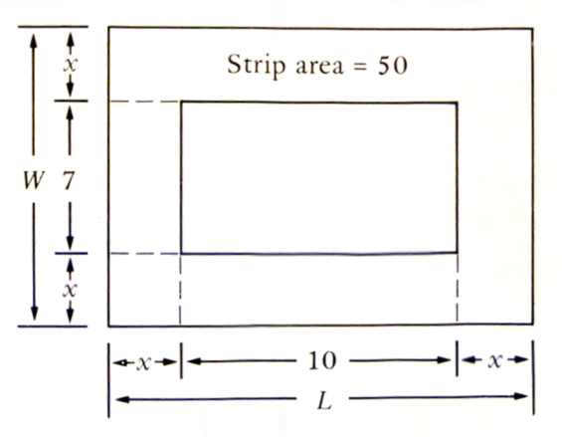A 7-inch by 10-inch rectangle has a strip of uniform width, x inches, around its outside. If the area of the strip is 5 0 square inches, what is the width of the strip?

Find the equation for the following graph:

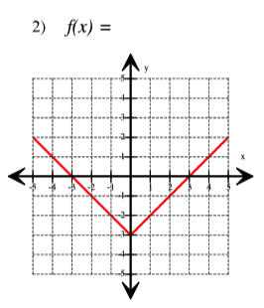

Identify the information for the following quadratics.

3) y=3x2+7x

i) a = b = c =

ii) Vertex = ( , )

iii) Line of symmetry: x =

iv) Open up / down?

4) y=1.7x2+2.3x+1

i) a = b = c =

ii) Vertex = ( , )

iii) Line of symmetry: x =

iv) Open up / down?

Solve

7) (7x + 8)(2x – 11) = 0

8) x2 + 4x – 5 = 0

9) 10)

11) 12)

13) |x+2| = 2.3 14) |5x-28|=49

11) Football

A ball is thrown from a height of 6 feet with an initial upward velocity of 32 feet per second.

1. Create an equation modeling this situation.
2. How high will the ball be a half second after it is thrown?
3. What is the maximum height the ball reaches?
4. When will the ball be 12 feet high?

12) Put the following equation into vertex form: y = 3x2 – 24x +55

13) Give the equation: y = 2(x-3)2-9

a) What is the vertex of the function?

b) Does this function open up or down?

c) Put the function in standard form.