Algebra 1

Chapter 9: Exponents and Exponential Functions

**Chapter 9b and 9c Review**

**Match each graph with its equation.**

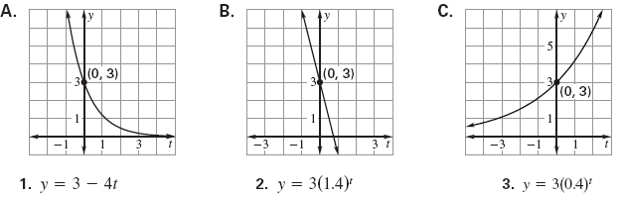

**Write the growth factor used to model each percent of increase in an exponential function.**

4) 3% 5) 6.8% 6) 0.5%

**Write the decay factor used to model each percent of decrease in an exponential function.**

7) 2% 5) 3.4% 6) 20%

**Classify the model as exponential growth or exponential decay. Identify the growth or decay factor and the percent increase or decrease per time period.**

7) y =  8) y =  9) y = 

a) Growth or Decay? a) Growth or Decay? a) Growth or Decay?

b) Growth/Decay Factor: b) Growth/Decay Factor: b) Growth/Decay Factor:

c) Percent Increase/Decrease: c) Percent Increase/Decrease: c) Percent Increase/Decrease:

10) y =  11) y =  12) y = 

a) Growth or Decay? a) Growth or Decay? a) Growth or Decay?

b) Growth/Decay Factor: b) Growth/Decay Factor: b) Growth/Decay Factor:

c) Percent Increase/Decrease: c) Percent Increase/Decrease: c) Percent Increase/Decrease:

13) From 1990 to 2000, the tuition at a college increased by about 8% per year. Use the graph below to write an exponential growth equation.

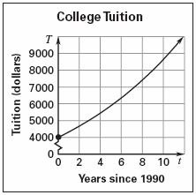

15) A business had an $11,000 profit in 1995. Then the profit increased by 15% per year for the next 5 years.

a) Write an exponential growth model.

b) Graph the exponential growth model.



14) Between 1970 and 2000, the population of a city decreased by approximately 2% each year. In 1970 there were 600,000 people. What was the population in 2000?

16) Between 1990 and 2000, the profits of a business decreased by approximately 0.5% each year. In 1990 the business’s profit was $2 million. Write an exponential decay model showing the business’s profit P in year T. What was the profit in 2000?