**Solving an Absolute-Value Equation**

1. |x| = 5
2. 3|x| = 12
3. |x|+4 = 13
4. |x-6| = 17
5. |x+9| = 4
6. |2x-16| = 48

**Graphing an Absolute-Value Equation**

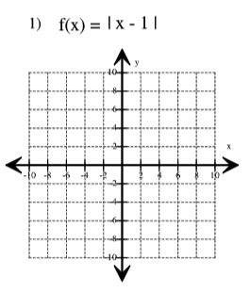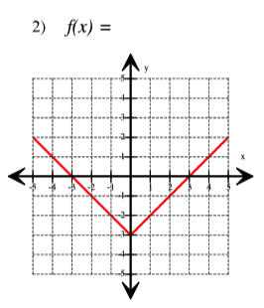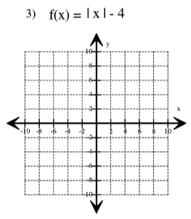

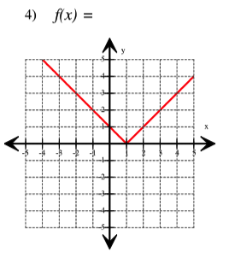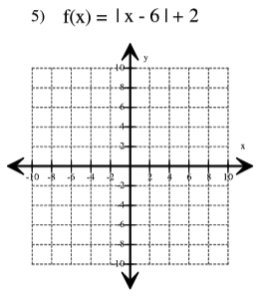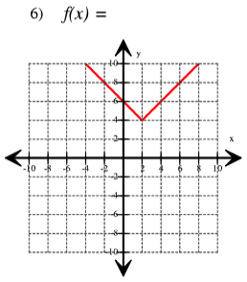

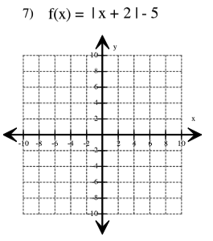 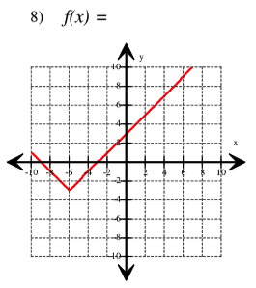

**Exponential Properties**

1) 

2) 

3) 

4) 

5) 

**Creating a Function given the multiplier and the starting-value**

1. Growth of 3.4% starting at 15. Create a Next,Now equation and y,x equation
2. Decay of 22% starting at 150.

**Creating a Sequence Given a Function**

3) y = 

|  |  |  |  |  |  |
| --- | --- | --- | --- | --- | --- |
| **x:** | **0** | **1** | **2** | **3** | **4** |
| **y:** |  |  |  |  |  |

b) Where does the function start when x = 0?

c) As ‘x’ gets larger, does the function increase or decrease?

4) Next = Now * 2, starting at 1.5

|  |  |  |  |  |  |
| --- | --- | --- | --- | --- | --- |
| **x:** | **0** | **1** | **2** | **3** | **4** |
| **y:** |  |  |  |  |  |

b) Where does the function start when x = 0?

c) As ‘x’ gets larger, does the function increase or decrease?

**Creating a Function Given a Sequence**

5)Fill in the rest of the table and create equations:

Next,Now Equation:

‘y =’ Equation:

|  |  |  |  |  |  |  |  |
| --- | --- | --- | --- | --- | --- | --- | --- |
| **x:** | **0** | **1** | **2** | **3** | **4** | **5** | **6** |
| **y:** | 60 | 40 |  |  |  | ?____ | ?____ |

**Interpreting a Function**

6) 

Growth or Decay?

Percent increase/decrease?

7) 

Growth or Decay?

Percent increase/decrease?

**Creating a Function to Describe a Context**

8) **Penicillin** (the 1st antibiotic) has a 40% decay in 1 hour.

a) What do x and y represent in the situation?

b) Find the percent of penicillin in the blood after 5 hours.

9) **Automotive**: A new car depreciates at about 13% per year (on average) If I buy a car for $18,995

a) Write equations representing this situation.

Next = Now ______ starting at ____

y =

b) What do x and y represent in this situation?

c) What will the car be worth after 5 years?

d) How long will it take for the car to depreciate to half of its original value?

10) **Population:** The world population in 1997 was 5.861 billion growing at a rate of 1.4% per year (source: World Bank).

1. Write a ‘y =’ equation for this situation
2. Use your equation to estimate the world population in 2013.
3. The actual population in 2013 was 7.125 billion (source: World Bank). How did your equation do?
4. If your estimate was off by more than 0.5 billion, did the actual population growth rate increase or decrease over the years?

11) **Medical:** When people suffer head injuries in accidents, emergency medical personnel sometimes administer a paralytic drug to keep the patient immobile. If the patient is found to need surgery, it’s important that the immobilizing drug decay quickly.

For one typical paralytic drug the standard dose is 50 micrograms. One hour after the injection, half the original dose has decayed into other chemicals. The halving process continues the next hour, and so on.

1. How much of the 50 micrograms will remain in the patient’s system…

After 1 hour? After 2 hours? After 3 hours?

1. Write an equation for calculating the amount of drug that will remain ‘x’ hours after the initial dose.
2. How long will it take the 50 microgram dose to decay to less than 0.05 micrograms?

12) **Population**: Between 1970 and 2000, the population of Detroit, MI (my hometown) decreased quite a bit. In 1970 the population was 1,502,792 and in the year 2000 the population had declined to just 951,270. (source: detroitmi.gov)

a) Write an equation that models this situation. Use what you know to find the “a” and “b” values in the general exponential function.

b) The US Census Bureau has the 2010 population of Detroit at 713,777. What does your equation give as population estimate for 2010?

13) **Radioactive Strontium-90:** Radioactive materials have many important uses in the modern world, from fuel for power plants to medical x-rays and cancer treatments. But the radioactivity that produces energy and tools for “seeing” inside our bodies has some dangerous effects too, for example, it can cause caner in humans.

The radioactive chemical strontium-90 is a by-product of producing nuclear energy. Extreme care must be taken in transportation and disposal of this substance. It decays rather slowly—if any amount is stored at the beginning of a year, 98% of that amount will still be present at the end of that year.

1. If 100 grams (about 0.22 pounds) of strontium-90 are released due to an accident, how much of that radioactive substance will still be around…

After 1 year? After 2 years? After 3 years?

1. Write two different equations that can be used to calculate the amount of strontium-90 remaining at any year in the future, from an initial 100 grams. (Next,Now and y =)
2. Use one of the equations in part b to find the amount of strontium-90 left from an initial amount of 100 grams after 15.5 years.