Geometry – Chapter 9 Review Tasks

Triathlon
There is a big triathlon in town, and you want to take pictures of your friends at multiple locations during the event. How far would you need to walk to move between the photography locations?
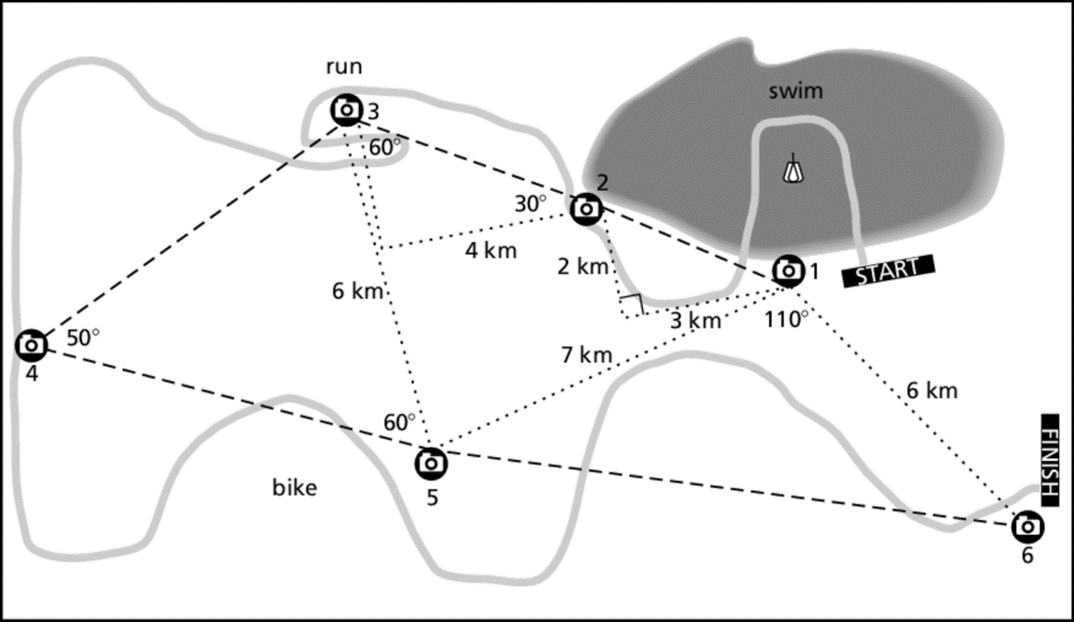

You will travel along the dashed path from Station 1 through Station 6. Use the information provided to find the distances between each photography spot.

Complete this problem on a separate sheet of paper. Name the theorem or property used (i.e. law of cosines) and show all relevant work for your solution method.

1. Station 1 to Station 2
2. Station 2 to Station 3
3. Station 3 to Station 4
4. Station 4 to Station 5
5. Station 5 to Station 6

Baseball
A baseball diamond is a square, 90ft on a side, with home plate and the three bases as vertices. The pitcher’s mound is located 60.5ft from home plate on a direct line from home to 2nd. Find the distance from the pitcher’s mound to each of the bases. [Hint: The pitcher’s mound is NOT located on a direct line from 1st to 3rd base.]

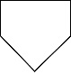
Home
3rd
1st
2nd
Pitcher

- Pitcher to home base
- Pitcher to 1st base
- Pitcher to 2nd base
- Pitcher to 3rd base

