- Graph a line of best-fit and find the equation for the line. Be sure to show any relevant work.

Explain what your line predicts based on the situation in the scatterplot.

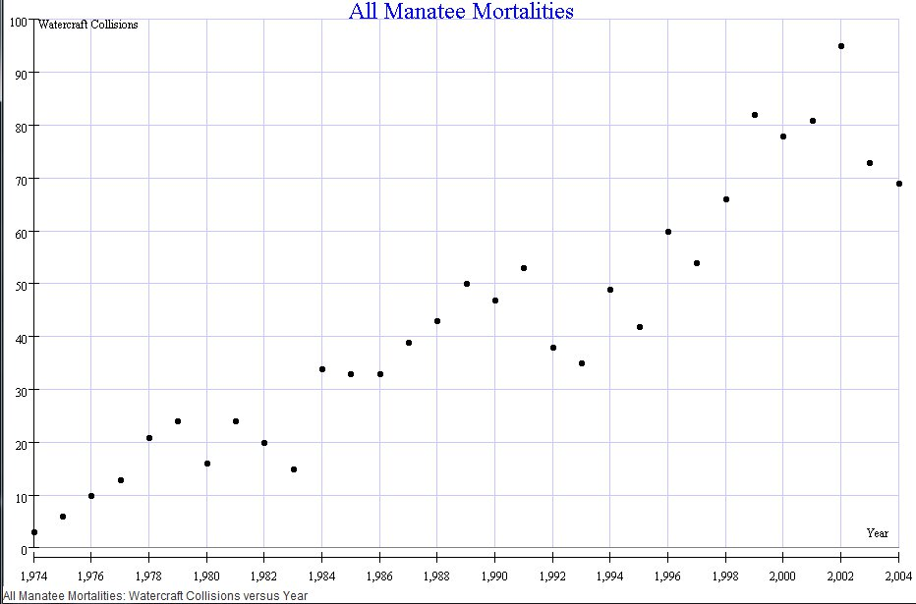

- State the domain and range of each graph.
[Please note, I’m intentionally being vague about the scale. This isn’t a “how to” model for graphing]
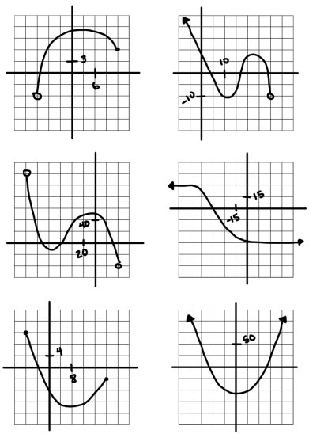

- Tara’s car travels about 25 miles on one gallon of gas. She has between 10 and 12 gallons of gas in the tank.
  - List the independent and dependent quantities.

  - Find the reasonable domain and range values.

  - Write the reasonable domain and range values as inequalities.

