Alfredo Gomez is designing patios. Each patio has a rectangular garden area in the center. Alfredo uses black tiles to represent the soil of the garden. Around each garden, he designs a border of white tiles. The pictures shown below show the three smallest patios that he can design with black tiles for the garden and white tiles for the border.
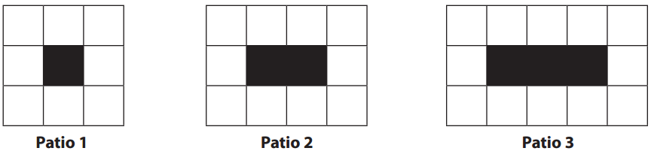
- Draw patio 4 and patio 5. How many white tiles are in patio 4? Patio 5?

- Make some observations about the patios that could help you describe larger patios.

- Describe a method for finding the total number of white tiles needed for patio 50 (without constructing it).

- Write a rule that could be used to determine the number of white tiles needed for any patio. Explain how your rule relates to the visual representation of the patio.

- Write a different rule that could be used to determine the number of white tiles needed for any patio.
Explain how your rule relates to the visual representation of the patio.

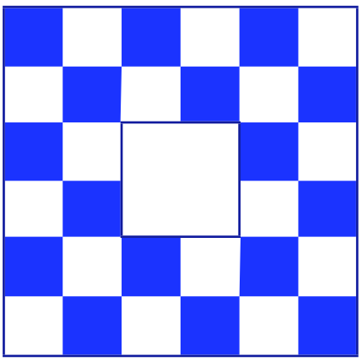
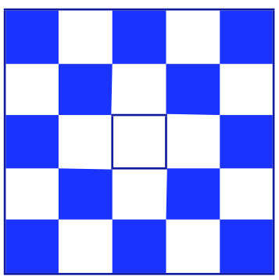
1st iteration 2nd iteration

3rd iteration 4th iteration

How many colored tiles are in the 20th iteration? (20 by 20 white tiles in the center)

How many colored tiles in the 100th iteration? (100 by 100 white tiles in the center)

Extension:
What will it cost to tile the entire 100 by 100 floor if tiles cost:
$3.19/Sq. Ft. for lighter tiles.
$3.45/Sq. Ft. for Darker tiles

