**For each of the following problems, fill in the equation, table and graph using the given information. For example, if you’re given the graph, you should fill in the table and create an equation.**

1) y = -2x + 7

|  |  |  |  |  |
| --- | --- | --- | --- | --- |
| x |  |  |  |  |
| y |  |  |  |  |

|  |  |  |  |  |
| --- | --- | --- | --- | --- |
| x | 1 | 2 | 3 | 4 |
| y | -4 | -2.5 | -1 | 0.5 |



2) y =

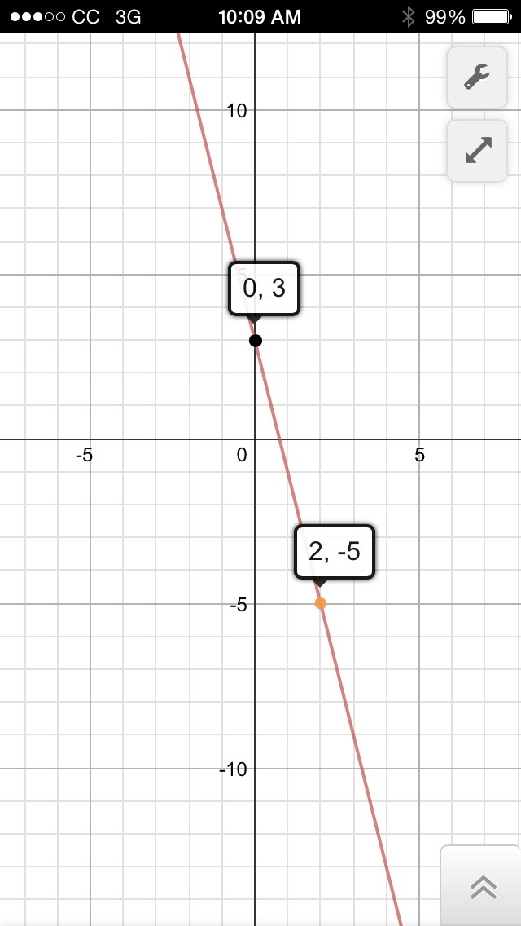

3) y =

|  |  |  |  |  |
| --- | --- | --- | --- | --- |
| x |  |  |  |  |
| y |  |  |  |  |

**Graph the equations without converting to a different form.**

4) 5)



**First solve the following system through graphing. Then solve through either substitution or elimination.**



6) $\left\{\begin{aligned}y=\frac{5}{2}x+7 \\ y=\frac{-1}{2}x-5\end{aligned}\right.$

1. Solution using graphing:
2. Solution using the other method:  
   (you must show work for credit)

**First solve the following system through graphing. Then solve through either substitution or elimination.**

7) $\left\{\begin{aligned}y=\frac{7}{3}x+5 \\ 5x-8y=1\end{aligned}\right.$

1. Solution using graphing:
2. Solution using the other method:  
   (you must show work for credit)

8) Negative City used to be a decent sized city but things haven’t been going so well. Over the last several years, on average, they’ve been losing 3,000 people per year. This year their population is down to 100,000 people. Positive-ville is a small city experiencing huge amounts of growth relative to its size. They’ve been growing at a rate of about 2,000 people per year. Their population is now up to 50,000 people. If these trend continues, how long will it take for these two populations to reach the same size.

9) For the following pattern:

Figure #: 1. 2. 3.

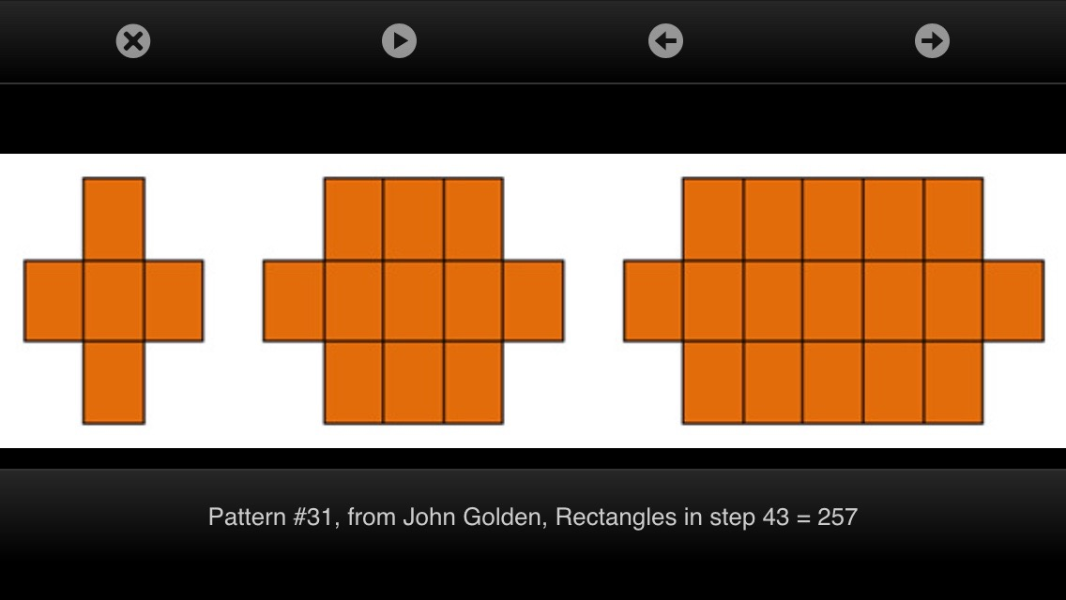

* 1. Draw the next figure in the sequence.
  2. Find the number of blocks in the 5th figure.
  3. Find the number of blocks in the 60th figure.
  4. Create an equation relating the figure number to the number of blocks.