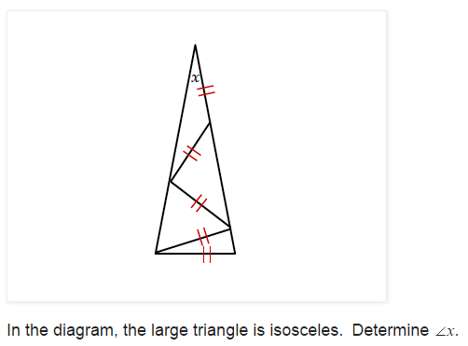
5-7 Challenge Problem:
Taken from this page on fivetriangles.blogspot.com.

