1) List three sequences of transformations that take pre-image ABCD to image A’B’C’D’. (Challenge: Can you get there in less?)
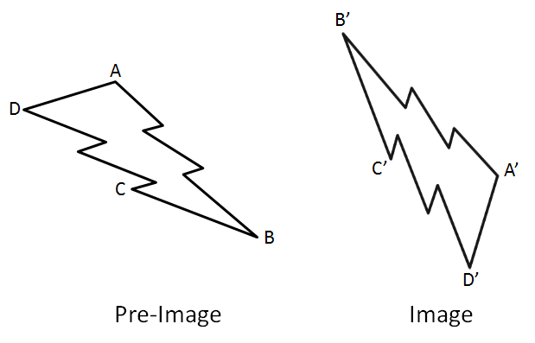

2) For quadrilateral ABCD and A’B’C’D’ below:

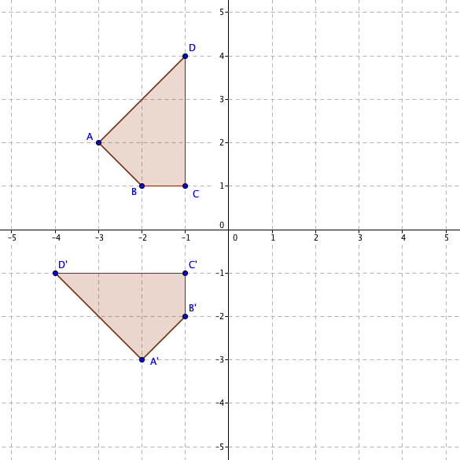
a) Find a single transformation mapping ABCD onto A’B’C’D’.

b) Find a sequence of two transformations mapping ABCD onto A’B’C’D’

For the following problems, start with polygon ABCDEF, draw each successive transformation on the graph and give the rule to get there.

3) Reflect ABCDEF across the line y=x → GHIJKL
T(x,y) → ( , )

4) Rotate GHIJKL 90 degrees counter-clockwise around the origin → MNOPQR
T(x,y) → ( , )

5) Rotate MNOPQR 90 deg counter-clockwise with center (1,-2) →STUVWX
T(x,y) → ( , )

6) Translate STUVWX 4 units to the right and 2 units up →A’B’C’D’E’F’
T(x,y) → ( , )

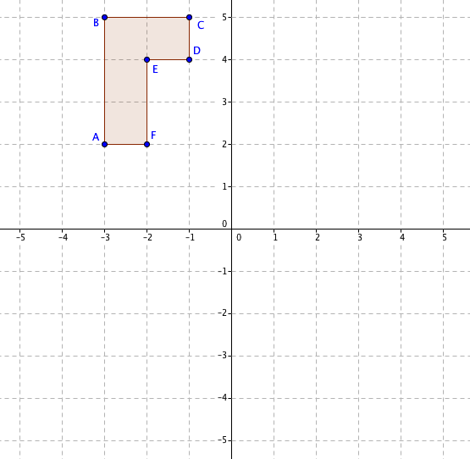

7) Given ABCDEF → A’B’C’D’E’F’, what is the rule describing the transformation?
T(x,y) → ( , )
8) Rotate point A(-2, -3) 90 degrees clockwise around center B(1, 2)
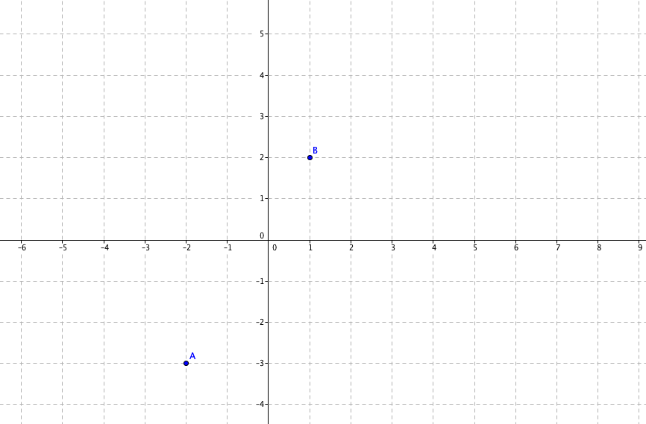

9) Rotate the point (m, n) 90 degrees clockwise around center (1, 2)

10) Rotate the point (m, n) 90 degrees clockwise around center (h, k)

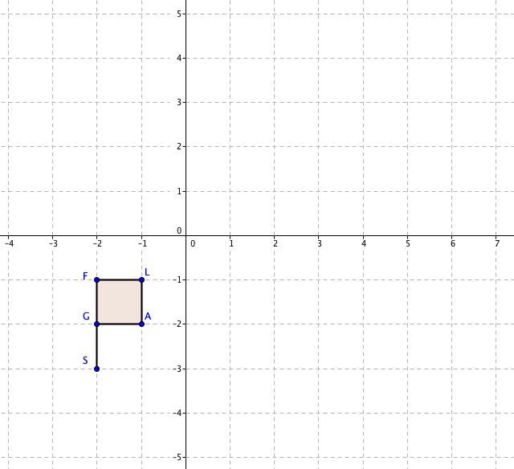
11) Given the transformation, T(x,y) → (y+1, -x + 3), draw T(FLAGS) → F’L’A’G’S’

Is this a reflection, rotation, or translation?

How do you know?

