**Topics covered:**

1. **Unit Circle (exact values, degrees, and radians)**

Using the unit circle below, fill in the degrees, radians, and exact values for each coordinate.

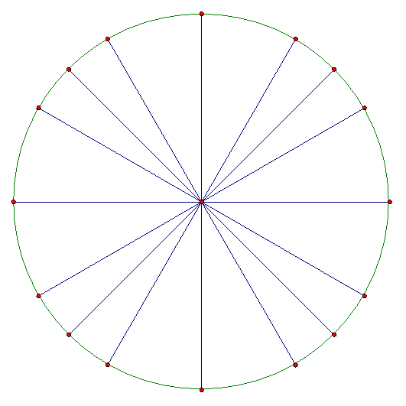

1. **Trigonometric Functions and Relationships**

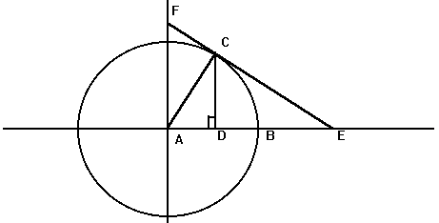1. Using the unit circle below, label: sin θ, cos θ, tan θ, sec θ, csc θ, cot θ

2. Locate the point for which the given value is the appropriate coordinate on the unit circle. Draw the right triangle and give the exact value.

A. sin (60°) = _____ B. cos (3π/4 ) = _____



C tan (330°) = _____ D. sin (7π/4) = _____



E. cos (270°) = _____ F. tan (7π/6) = _____



G. cos (210°) = _____ H. sin (4π/3) = _____



3. Solve the following right triangles for the marked angle or side. Show all your work and round your final answer to the nearest hundredth.

* 1. . b.

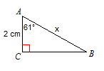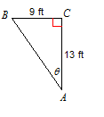

4. Solve the following application problems using trigonometry:

A. A beautiful blue kite is attached to the back of your boat on a 250 foot string. As the speed of the boat increases the kite rises into the air. When the string is taut the kite’s angle of elevation is 40°. What is the horizontal distance between the kite and the boat? Round only your final answer to the nearest tenth if necessary.

B. A flagpole is placed on top of the building. From a point on the ground 220 ft from the base of a building, the angles of elevation of the top and bottom of the flagpole are 70° and 57°. Find the height of the flagpole. Round only your final answer to the nearest tenth if necessary.

1. **Trig Identities**

I’m not going to ask for trig identity proofs on the test.

1. **Law of Sines and Law of Cosines**

1. Write the Law of Sines and give an example of a triangle in which you would use the Law of Sines.

2. Write the Law of Cosines and give an example of a triangle in which you would use the Law of Cosines.

3. Given a triangle with a = 16, b = 37, and c = 32, find the area.

In numbers 4 and 5, find all of the missing measurements to the triangle:

4. b = 40, c = 45, A = 51°

5. A = 38°, B = 63°, c = 15

6. The bearing of a lighthouse from a ship was found to be N 37 degrees E. After the ship sailed 2.5 miles due south, the new bearing was N 25 degrees E. Find the distance between the ship and the lighthouse at each location.

7. A baseball diamond is a square, 90ft on a side, with home plate and the three bases as vertices. The pitcher’s mound is located 60.5ft from home plate on a direct line from home to 2nd. Find the distance from the pitcher’s mound to each of the bases.

8. A surveyor sights a tree directly across a river and then measures 80 feet along the bank. At the new location, she finds the angle between the riverbank and her line of sight to the tree is now 42 degrees. How wide is the river?

1. **Cosine Function**

$$f\left(x\right)=a*cos\left(\frac{2π}{p}*(cosθ-h)\right)+k$$

**-or-**

$$f\left(x\right)=a*cos\left(\frac{360}{p}*(cosθ-h)\right)+k$$

What does each letter stand for in the equation?

a:

p:

h:

k:

**Write the cosine function for each graph.**

1. 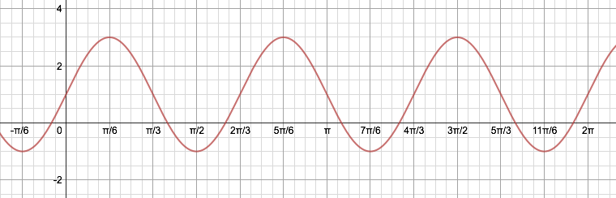

Cosine Equation:

|  |  |
| --- | --- |
| Amp |  |
| Period |  |
| Horizontal Shift |  |
| Vertical Shift |  |

2. 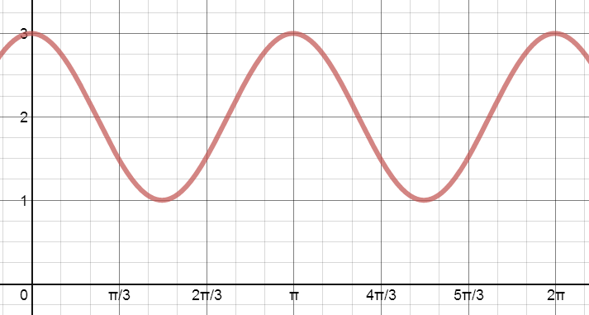

|  |  |
| --- | --- |
| Amp |  |
| Period |  |
| Horizontal Shift |  |
| Vertical Shift |  |

Cosine Equation:

3.

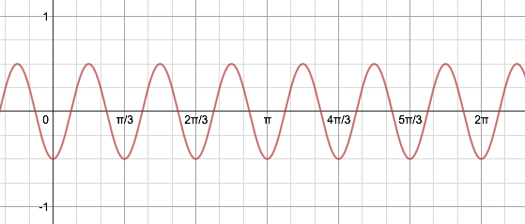

Cosine equation:

|  |  |
| --- | --- |
| Amp |  |
| Period |  |
| Horizontal Shift |  |
| Vertical Shift |  |

4.

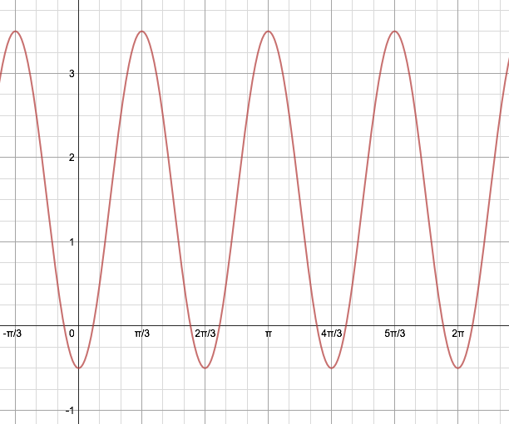

|  |  |
| --- | --- |
| Amp |  |
| Period |  |
| Horizontal Shift |  |
| Vertical Shift |  |

Cosine equation: