This diagram shows a circle with one equilateral triangle inside and one equilateral triangle outside.

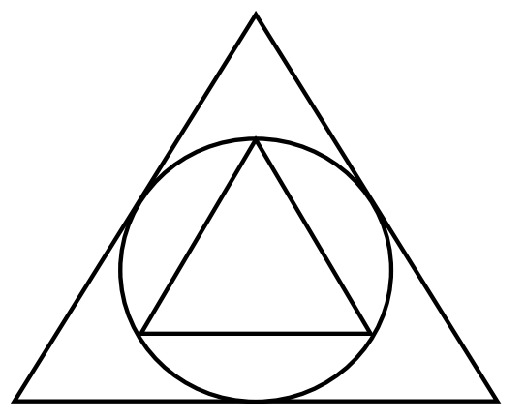

- Find the exact ratio of the areas of the two triangles. Be convincing in your explanation.

- Draw a second circle inscribed inside the small triangle. Find the exact ratio of the areas of the two circles. Be convincing in your explanation.

