##### 10h - Patchwork Cushions

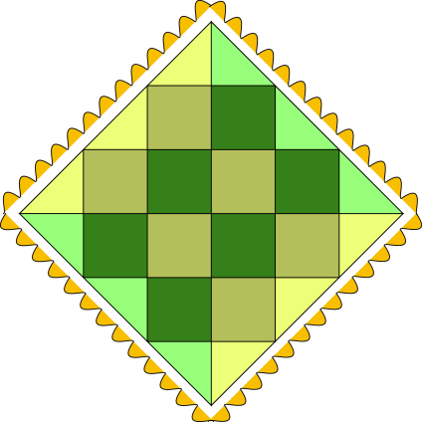

Kate makes patchwork cushions by sewing together right angled triangles and squares. She uses triangles along the edges of each cushion, the rest is made from squares.

The backs of the cushions are made from plain material, not patchwork.

Kate makes cushions in different sizes.



1. Kate wants to know how many triangles and squares she needs for a size 5 cushion
2. Can you find rules or formulas that will help Kate find out how many squares and triangles she needs for cushions of other sizes? Explain your thinking so that Kate understands it.

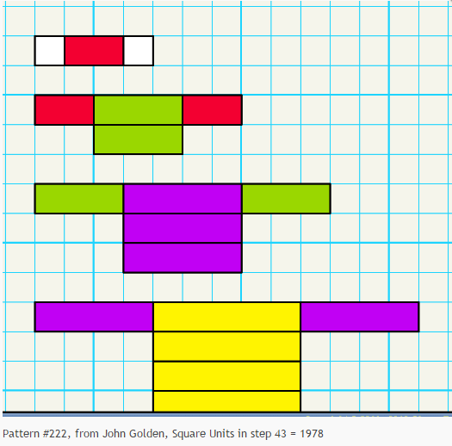

1. Draw the next step in the pattern. from visualpatterns.org
2. Find the number of blocks in the 20th step. Be sure to include all relevant work.
3. Find an equation. Be sure to include all relevant work.